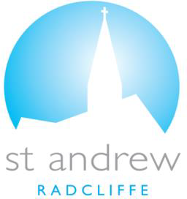

For all of you who were baptised into Christ have clothed yourself with Christ Galatians 3:27
Celebrating the Gift of your Child
We are a lively parish at St Andrew’s, bringing the joy and hope of Jesus and we offer two wonderfully different services in which we can Celebrate the gift of your Child dependant on your journey of faith everyone is warmly welcome at St Andrews.
Christenings (service of Thanksgiving) The Christening Service is a wonderful way to thank God for the gift of your child as you decide what is next for you in your journey of Faith. These are private services held after our main Sunday service at 12pm. In this service your child is blessed with their ‘Christian’ name and sponsors (equivalent of Godparents) who are invited to support your child and of course parents/guardians in the years to come. There is no preparation required and services can be arranged by mutual agreement.
Holy Baptism (with Holy Water) is a service held within our main Sunday service. As this is an official declaration of a commitment to a life-long journey of Faith with God that we book a a provisional baptism date and we require families to attend at least 4 services over a two-month period before the baptism and attend a Baptism preparation session. It is a wonderful way to also involve your children’s godparents and for them to be involved at all stages of your child’s Baptism journey in Faith as they pray. We have our wonderful Sunday morning service at 10am ‘All Ages at All Stages’ or why not join us at our wonderful All Age Service each Thursday? Dates of baptisms are restricted to monthly scheduled dates.
If you would like to arrange to talk about Celebrating the Gift of your Child at St Andrews church, please contact:
Mrs Diane Moran on 07565 503830 or by email at diane.moran1@btinternet.com
Diane will be your point of contact as you prepare for your service which we hold within our wonderful St Andrews Church Building.
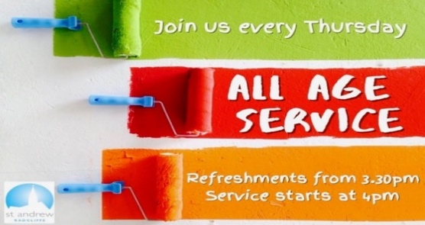

If have a celebration and would like to donate:
- You can pop it into the envelope on your pew.
- Pay by card on our card reader or
- Send a direct payment to:
StAndrew Radcliffe PCC, Account Number: 12240415, Sort Code: 16-29-20
We are so grateful for any donations made and they are used within our Church Ministry

